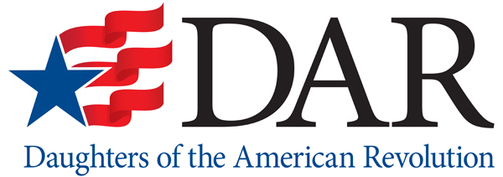
NEWS
CHAPTER AND/OR MEMBER NAME
ADDRESS
CITY, STATE ZIP
WEBSITE URL

Press contact:

FOR IMMEDIATE RELEASE NAME
DATE PHONE

EMAIL

DAR Surpasses One Million Members Since its Founding
[CHAPTER NAME] Marks Milestone by Celebrating its Local Members

LOCAL CITY, STATE – This fall the National Society Daughters of the American Revolution (DAR) will surpass ONE MILLION total members who have joined the organization since its founding in 1890. The DAR is a women’s service organization whose members can trace their lineage to an individual who contributed to securing American independence during the Revolutionary War.

The [CHAPTER NAME] DAR Chapter, based in [CITY, STATE] has welcomed [TOTAL MEMBERSHIP SINCE CHAPTER’S FOUNDING] since the chapter began in [YEAR CHAPTER BEGAN]. [CHAPTER NAME] is excited to join the National Society in celebrating this milestone by spotlighting members of the chapter through the years.

Throughout [CHAPTER NAME]’s [CHAPTER’S AGE] -year history, its membership has included many remarkable women from the local community.

[HIGHLIGHT A FEW MEMBERS OF YOUR CHAPTER, MIX IN CURRENT MEMBERS AND HISTORIC MEMBERS (IF YOUR CHAPTER HAS BEEN IN EXISTENCE FOR MORE THAN A FEW YEARS). CHOOSE MEMBERS THAT HAVE UNIQUE STORIES, CAREERS AND ACHIEVEMENTS TO SHOW THE DIVERSITY OF WOMEN WHO JOIN DAR. FOR EXAMPLE:

Mary Jones joined the chapter in 1976. At the time she was a young mother, but became interested in genealogy with all of the excitement of the Bicentennial and decided to join the chapter. She worked as an elementary teacher for 30 years and after retiring became very active within many different DAR initiatives and she is still an active member of our chapter today.

Sally Smith joined DAR 5 years ago when she was in law school. Today she is a practicing attorney and a young mother, and although she is very busy she makes time for DAR and gives back to her community by volunteering with her church.]

These are just [NUMBER OF MEMBER PROFILED ABOVE] of the one million women who have joined DAR since 1890. Each DAR member has a unique story, but all share a passion for historic preservation, education and patriotism and a dedication to her local community. .

The [NAME OF CHAPTER] DAR Chapter focuses much of its efforts on [PROJECTS THE CHAPTER SUPPORTS]. The chapter encourages women interested in DAR membership to [INCLUDE INFORMATION ON HOW YOU WANT PROSPECTIVE MEMBERS TO BECOME ACQUAINTED WITH YOUR CHAPTER – FOR INSTANCE PROVIDING INFORMATION ON AN UPCOMING CHAPTER MEETING OPEN TO PROSPECTIVE MEMBERS OR A GENEALOGY WORKSHOP SPONSORED BY THE CHAPTER, ETC.]

If you are interested in learning more about DAR membership, visit [CHAPTER WEBSITE OR FACEBOOK] or contact [CONTACT INFO].

# # #

The National Society Daughters of the American Revolution was founded in 1890 to preserve the memory and spirit of those who contributed to securing American independence. For more than 125 years, the DAR has strived to bring awareness to the honorable sacrifices and enduring legacy of all patriots who fought for America’s freedom. Through the DAR Genealogical Research System (www.dar.org/GRS), the public can access a free database of information amassed by the DAR about these patriots. DAR is a nonprofit, nonpolitical women’s service organization with more than 185,000 members in approximately 3,000 chapters worldwide. Any woman 18 years or older, regardless of race, religion, or ethnic background, who can prove lineal descent from a patriot of the American Revolution is eligible for membership. DAR members passionately carry out the timeless mission of promoting historic preservation, education and patriotism. To learn more about the work of today’s DAR, visit www.dar.org.

